**PRACTICAL-9**

AIM- Create a Digital certificate.

Step-1: Fill the necessary details and click “Next Page”.

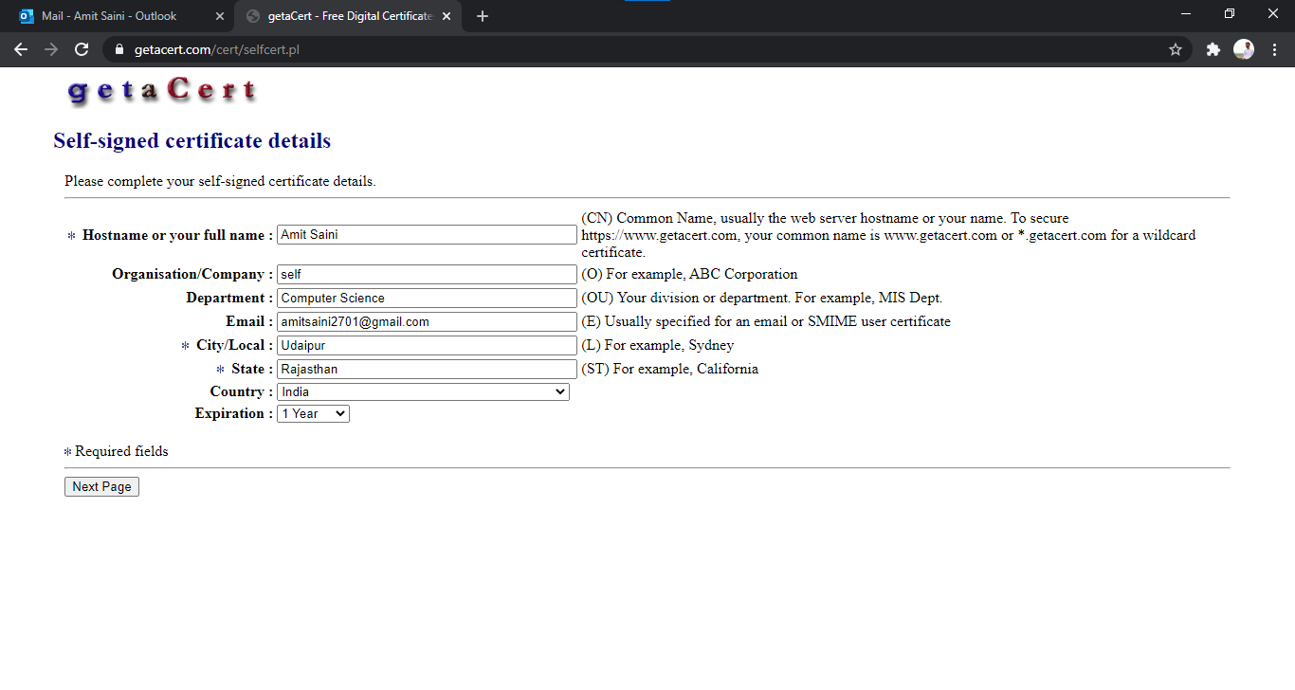

Step-2: Review the details and click on “Submit Self-Signed Certificate”.

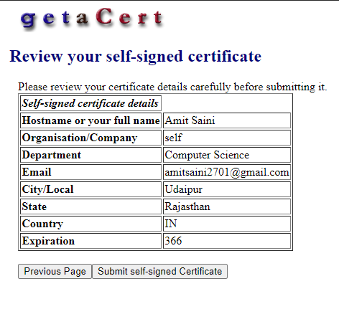

Step 3: Download certificate and open with internet explorer.

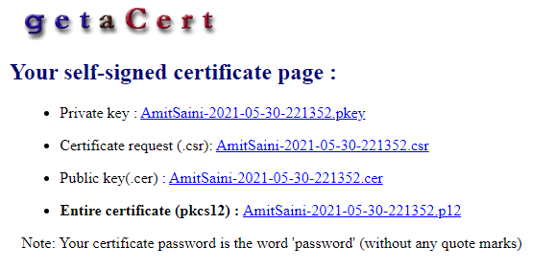

Note: The path of certificate fills automatically. And click Next Button.

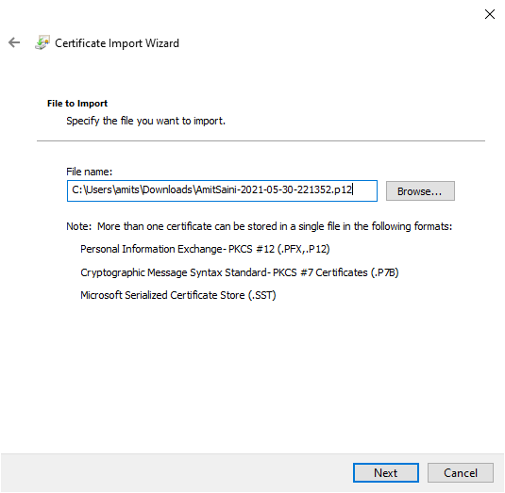

Step 4: Set password and click Next.

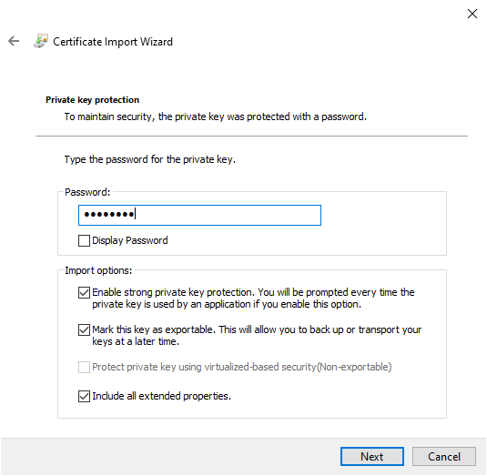

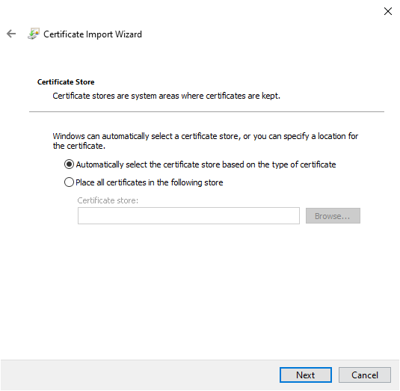

Step 5: Now finish yours process by clicking the Finish Button.

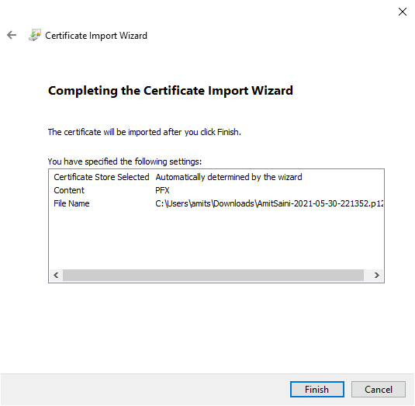

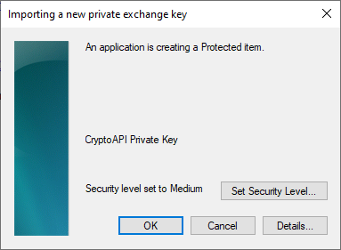

Result: Certificate successfully imported in Internet Explorer. Click Ok and see in internet option in Internet Explorer.

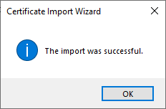

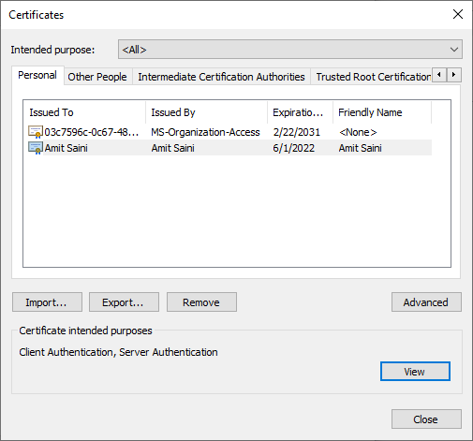

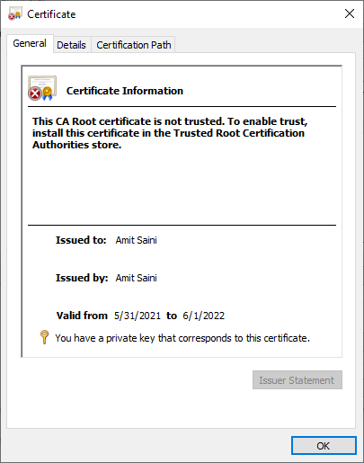

**PRACTICAL-10**

AIM- Write a program to calculate GCD using Euclid’s algorithm.

def gcd (a, b):

if a<b:

a, b = b, a:

if b==0:

return a;

return gcd(b,a%b)

a=int(input("Enter the first number:"))

b=int(input("Enter the second number:"))

print("GCD of",a,"and",b,"is:",gcd(a,b))

OUTPUT